Final project: the growth model for invasive plant species with no natural enemy

Modeling

In this project, I want to describe the phenomenon of invasive species. Invasive species is when a species that is not native to a specific location but is later introduced either by accident or on purpose mainly through the globalization of human society. Since they are not native to the new environment, they generally has no native enemy in the new location, which will result in them to reproduce much faster than the native species and be harmful for the environment.

So it will be interesting to know how the invasive species population growth after the initial invasion and what is the equilibrium state.

The stochastic model that is appropriate here is the logistic growth model.

Since there is no natural enemy, there is no other organism interacting with the species. As a result, the only limitation for the growth of the species is the natural resource available, in which the most important factor is living space. By assuming a certain amount of space is needed and the total space is limited, we can get the maximum capacity of how many of the species can grow in the environment, we can assign that number with N. so there are N sites available, each site can contain one individual of the species. The site can be empty or occupied by one individual.

Especially if we are studying plant, where once they occupied a certain site, they will not move. They will stay in the same site until they die. And their offspring can be assign to any site since most plants disperse their seeds wind or animal, which will result in them to appear at any site with the same probability. And if the seed goes to a site where there is already a plant, they cannot grow and just don’t reproduce. If the site is empty, they will occupy the site until they die. And for plant with no natural enemy, we can assume that they give birth at the same rate and die at the same rate.

This phenomenon fits well with the logistic growth model.

In the logistic model, there are N sites, each site either empty or occupied by one individual. Each individual can give birth at rate β or die at rate 1. And when giving birth, the offspring will be randomly assigned to a site. If the site is empty, the offspring will grow and if the site is occupied, the offspring will die, resulting in the growth to be suppressed.

So here I will use the logistic growth model to address the question about how the invasive species population grows after the initial invasion and what is the equilibrium state.

Analysis

From the text book (12.1), the transition rate is:

c(x, x + 1) := βx = βx (1 − x/N) and c(x, x − 1) := δx = x

for all x=0,1,2,…..,N,

To transform this equation into a programmable format, we will randomly choose a site after time of exponential distribution with parameter (β+1)*N. If the site is occupied, with probability β/(β+1), we will choose another site at random, if that site is empty, an offspring will occupy the site. And with probability 1/(β+1), the individual at the site will die. And if we chose a site that is empty, then nothing will happen. I will program this using R to show the simulated result with different β to show the effect of those parameters.

#define parameters

N=1000

betalist=c(0.5,1,2,5,10,20) # try different beta values and simulate the growth curve

T=5 #simulate until time T

outcome<-matrix(NA,ncol=length(betalist),nrow=T)

out<-NA

for (j in 1:length(betalist))

{

beta=betalist[j]

t=0

count=1

sites=rep(0,N)

for ( m in 1:10)

{

sites[m]=1

}

a<-c(beta,t,sum(sites))

out<-rbind(out,a)

while (N<10000)

{

u=runif(1,0,1)

lambda=(beta+1)*N

t=t-log(u)/lambda # the next update time

if(t>T){break}

i=sample(1:N,1)

# choose a site at random

if (sites[i]==1)

{

u=runif(1,0,1)

u=u*(beta+1)

if(u<1) # individual at sites[i] die

{

sites[i]=0

}

else

{

i=sample(1:N,1)

if(sites[i]==0) # choose another site and give birth if empty

{

sites[i]=1

}

}

}

a<-c(beta,t,sum(sites))

out<-rbind(out,a)

}

}

write.table(out,file="J:\\out.txt",quote=FALSE,row.names=FALSE,col.name=FALSE)

So here in this simulation, I used N=1000 and tested beta=0.5,1,2,5,10,20 and the result is below:

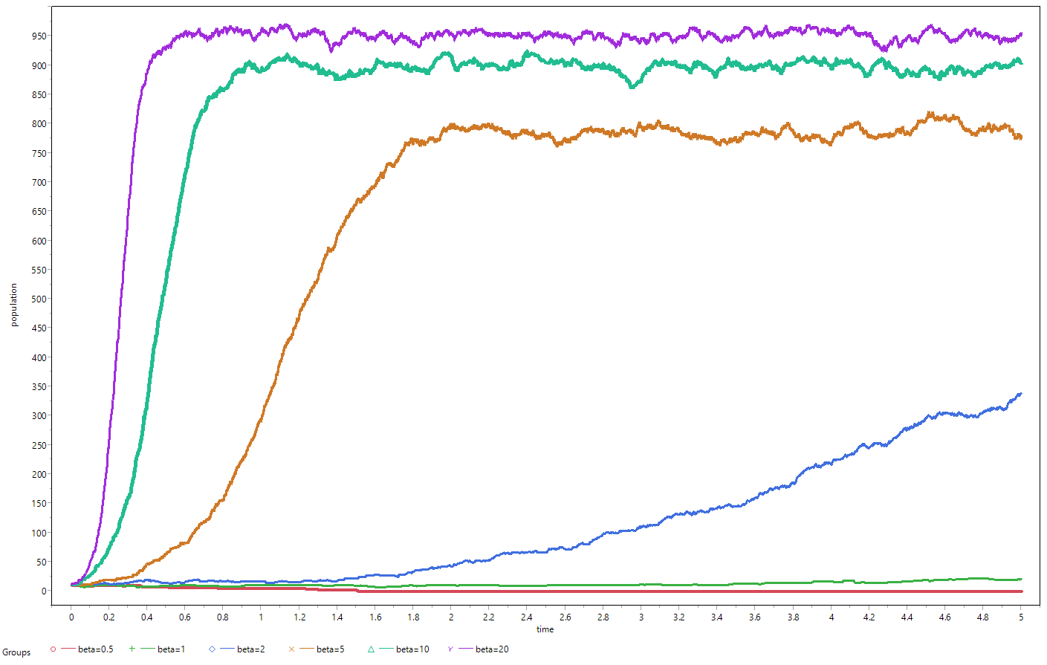

And about equilibrium state (here means the quasi-stationary distribution), as discussed in class, the quasi-stationary state will be around the carrying capacity. However, as it is illustrated in the figure above, the larger the birth rate β, the average population in the quasi-stationary distribution will be higher. This result can be explained better in deterministic logistic growth model the equilibrium state in when the birth rate equals the death rate ( βx=δx)

And as illustrated in class that at state

x= N (1 − β−1)

birth rate equals death rate. So the quasi-stationary distribution will be vibrate around that x value. The larger β is, the higher that value it will be. And since there is a upper boundary of full occupation where only death can happen, it will drop back from that boundary. However, at the lower boundary, when there is no population, no birth can be given, so if the time is long enough, in the stochastic process, the population will die out.

And if β<1, the population dies out very fast without going to the quasi-stationary distribution.

If β=1, the equilibrium state around the initial x value.

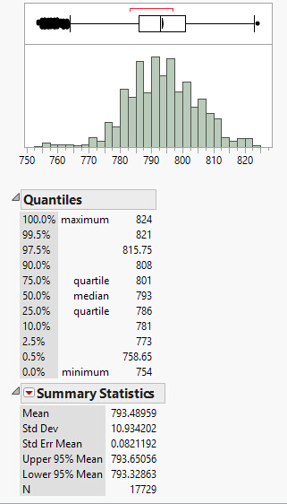

When you look at the population after they entered quasi-stationary distribution, here I illustrated using β=5 and t>2,

the population at different time points are near normal distribution, with a upper boundary of 1000, although never reached during simulation. Here I need to stress that since logistic growth process is markov chain, so the data points are not totally independent from each other, which violates the assumption, although the outcome is the same.

In class we have proven that the expected time to extinction for β>1 growth exponentially with size N. The expected time to extinct also increase significantly with the increase of β, although with an not easy to describe function.

Also, with the probability described in class that the population goes extinct quickly without going to the quasi-stationary state with β>1 is β−1, as a result, by estimating the β for invasive species in reality and how many invasive species are still existing, we can estimate how many invasive species are here in totally including the ones that failed to grow.

Conclusion

Now we can address the questions raised in the modeling part.

First, how the invasive species will grow. Based on very few assumptions, we can transform the model into logistic growth model.

Given the value of β, we know that

if β<1, it will die out quickly.

If β>1, with probability β−1, the species will die out fast.

Otherwise, the species will growth with S-like curve, in which it will first grow almost exponentially and then slow down and oscillate around the quasi-stationary state for a very long time before die out.

And the median value for the quasi-stationary state is N*(1 − β−1)

Second, what is the equilibrium state. From the analysis above, we know that the equilibrium state is the part where the species oscillates around the quasi-stationary distribution.

And here I call it the equilibrium state because the time needed for the species is too long, which is probability in reality larger than thousands of years given that the site N in reality is very big. As a result, it can be thought as impossible for the invasive species to die out by itself. And this is the reason why we cannot just wait for the species to die out instead of acting aggressively to control the spread of the species even though in theory they will die out at last without any interference.

And by looking at the simulation result, it will be best for the government to control the invasive species at the very early stage, because at early stage, the growth is very slow, constrainted by the low population. If we let the species to grow near the quasi-stationary state, it will be very hard to get rid of it, because the equilibrium state has self-stabilization ability.

And from the result of this model, we can gain useful statistics for the government to know from the number of successful invasive species the total number of all possible invasive species, which can be used for the government and provide information for the prevention in future.